How to Look up a Person, a Branch, an Award

Start here: https://op.antirheralds.org/index.php
HOW TO: Search the OP
OP stands for Order of Precedence. You can search the OP by typing the first letter of a person’s first name, or by the name, or part of the name if you’re not sure of the spelling into the search bar. If you were looking for me, Kateline, you could start with “kat” or “ka” and see search results with names that spell it this way but you wouldn't see the Caitlyn’s spell it with a "C".
Below is the top of the search result list based on my search for "kat". Continue scrolling down to find me.
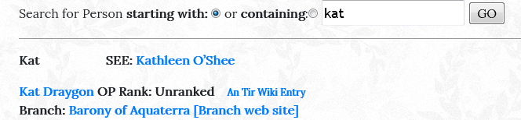
After scrolling, you will see me.
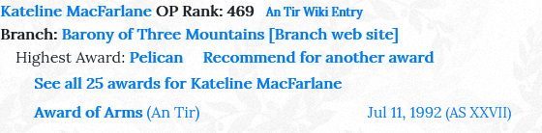

HOW TO: Recommend an Award
You can click on “Recommend for another award” on the OP and it will take you to the Kingdom page. Please remember to copy your Baron & Baroness too. You can find their email addresses on our Three Mountains Baronial website or ask for them. In our Tri-Barony area, consider sending a copy of your recommendation to all three Coronets! (Three Mountains, Dragon's Mist and Stromgard)
You can also click on “See all 25 awards for…” This will show all the awards that have been reported to Dexter Gauntlet Herald. It is very important for your branch herald to report all the awards given so that they are recorded.
HOW TO: Search by Branch
Below is an image of what is displayed if you choose “Awarded by Three Mountains”. Each branch or entity has its own list. Other choices for me are AnTir, Ithra, Stromgard and All. Also displayed are your registered arms. The pictures are linked from the Roll of Arms, which is maintained by Couronne Rouge Herald.
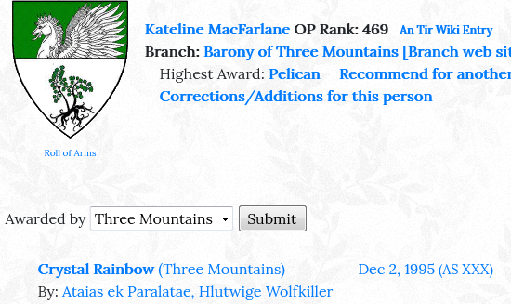

How TO: Search by Award
If you click on a award name, it will take you to the page where all the recipients of an award are listed, along with the Crown or Coronet and the date.
Looking up an individual to see if they have an award is one way to search the OP. Let’s go back to the beginning and I’ll show you some other ways to search.
VIEW THE WHOLE OP
You can also view the entire Kingdom in the OP. That’s how the heralds know who goes where in the procession at Crown Tournament. The King is listed first.
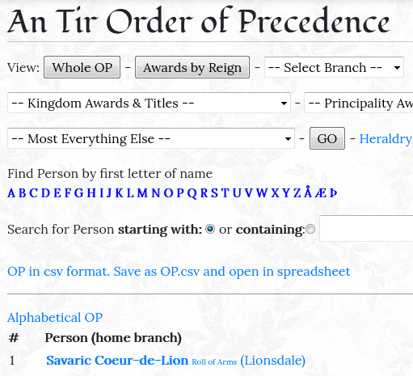

HOW TO: Search for an Award
Now let’s look for “Most Everything Else”, in this case the baronial award of the Golden Torc. All the awards for all the branches are listed alphabetically. Scroll down to find the one you want. Here’s the very first recipient.

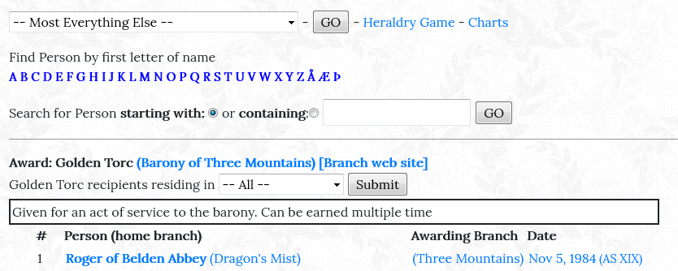
So now you can see if that person you’ve spotted washing dishes the last three events has received some recognition. If you click on their name it will take you to the listing that shows all the awards for that person.

HOW TO: Recommend for a Baronial Award
Start here: http://baronyofthreemountains.org/
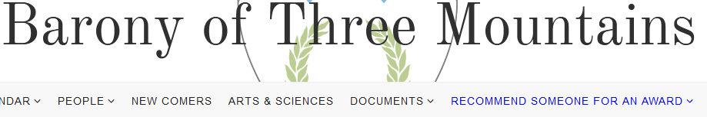

Information on the Barony’s awards is found on the Recommendation Page. Send your recommendation to: awardrecommendations@baronyofthreemountains.org
If you have questions about the recommendation process or the OP, please contact me at:
herald@baronyofthreemountains.org
Baroness Kateline MacFarlane, OP Mountains Pursuivant

